Cortez Lab Plasmid Map
Description: Added Flag+NLS and changed polylinker to match pBG101 into pLEGFP-C1
Plasmid: pDC1161
Alternate Name: pLEGFP-Flag-NLS
Creator: Dave Cortez
Date Created: 07/21/14
Antibiotic: AMP
DNA Location: 28:G6
Bacteria Location: 28:G6
Bacteria Strain: BW

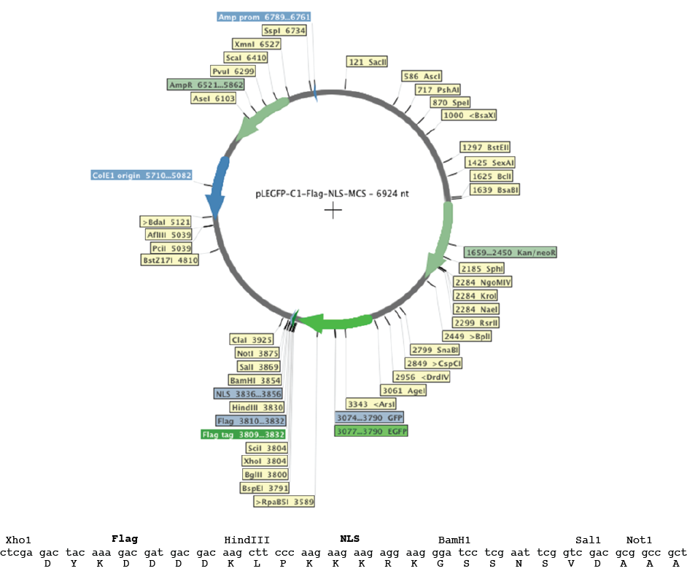
Map:

