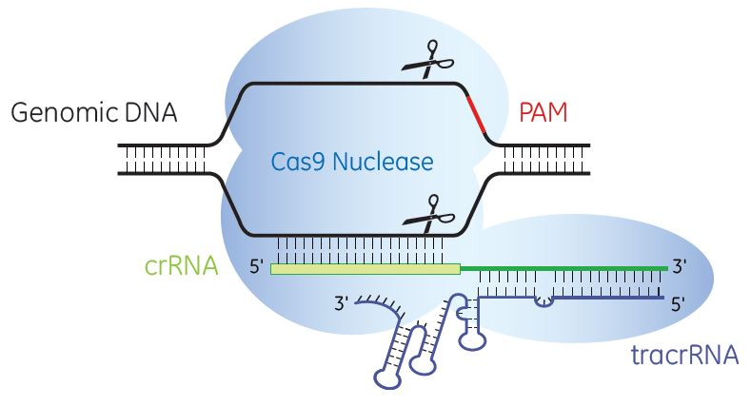
Cas9 mRNA + CrRNA/TracrRNA
Reagents:
- Edit-R Cas9 Nuclease mRNA CAS11860 Dharmacon, the option is GFP or RFP tag on the Cas9, you can sort the cell to enrich the transfected cell, usually not necessary.
- Edit-R tracrRNA Catalog #U-002005-05 Dharmacon
- Synthetic crRNA Pre-designed gRNA: https://dharmacon.horizondiscovery.com/gene-editing/crispr-cas9/crispr-guide-rna/synthetic-crrna/edit-r-predesigned-crrna/?rdr=true&LangType=2052&id=2147485982 Or design crRNA by yourself: https://dharmacon.horizondiscovery.com/gene-editing/crispr-cas9/crispr-design-tool/
Since Cas9 guide RNA design serve from Zhang’s Lab in MIT is shut down, I use https://benchling.com/ to design the gRNA. In the purpose of knockout a gene, I usually design a high scored single gRNA target the early exon of the gene. Two or more single gRNA can be designed for each knockout to improve the success. Then input the gRNA sequence into Dharmacon design tool website to synthesis.
- DharmaFECT Duo Catalog #T-2010-01 Dharmacon
- Opti-MEM cell media

Reagents preparation:

- Dissolve 20ug Cas9 mRNA in 200ul 1*siRNA buffer, final stock concentration should be 100ng/ul. Aliquot 20ul per tube, store in -800C, the RNA can be freeze and thaw up to 4 times.
- Dissolve CrRNA and TracrRNA in 1*siRNA buffer, respectively. Final stock concentration should be 10uM. Before use, mix crRNA and tracrRNA 1:1 and dilute 5 volume with siRNA buffer to a final concentration 2uM.

Transfection:

Day 1
- Plate 10000 U2OS cells (10000 RPE cells or 20000 293T cells) per well of 96 well plate.

Day 2
- For each well of 96 well plate, dilute 1.25ul CrRNA/TracrRNA mixture in 10ul opti-MEM, then add 2ul Cas9 mRNA, mix by pipetting. Dilute 0.5ul DharmaFECT Duo in another 10ul opti-MEM, mix by peptide, incubate 5minutes at RT.
- Combine two tube, carefully mix by pipetting, incubate at RT for 20 mins.
- Change fresh complete medium 80ul for each well.
- Add transfection mixture to growth medium, shake the plate to mix.

Day 3
- Split cells to 10cm dish to form colony, put the remaining cell to 6 well plate for western blot.
Cas9 protein + CrRNA/TracrRNA
Reagents:
- Edit-R Cas9 Nuclease protein Catalog #CAS11200 (20uM total 500pmol), Dharmacon
- CrRNA/TracrRNA same as last page.
- DharmaFECT Duo Catalog #T-2010-01 or DharmaFECT 1 Catalog #T-2001-01, (Duo is better, but 1 is acceptable), Dharmacon

Reagents preparation:

Dissolve CrRNA and TracrRNA in 1*siRNA buffer, respectively. Final stock concentration should be 10uM. Before use, mix crRNA and tracrRNA 1:1 and dilute 5 volume with siRNA buffer to a final concentration 2uM.

Transfection:

Day 1
- Plate 10000 U2OS cells (10000 RPE cells or 20000 293T cells) per well of 96 well plate.

Day 2
- For each well of 96 well plate, dilute 2.5 ul CrRNA/TracrRNA mixture and 1ul Cas9 protein in serum free medium, up to 50ul, mix by pipetting. Dilute 0.5ul DharmaFECT Duo in another 50ul serum free medium, mix by peptide, incubate 5minutes at RT.
- Combine two tube, carefully mix by pipetting, incubate at RT for 20 mins.
- Replace the medium with 100ul transfection mixture.

Day 3
- Change fresh complete medium

Day 4
- Split cells to 10cm dish to form colony, put the remaining cell to 6 well plate for western blot.

To screen single KO clone, design primer and sequence the genome PCR products.
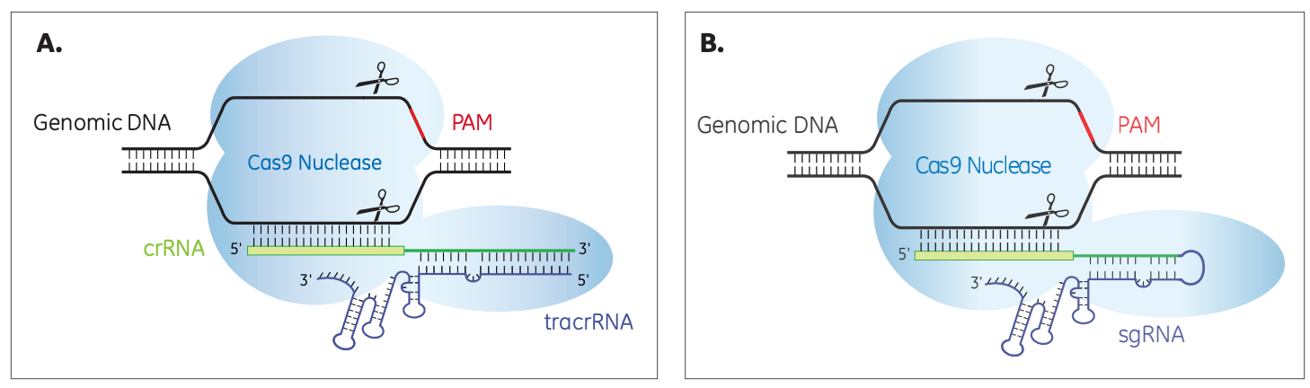
1uM sgRNA = 1uM mixture of CrRNA/TracrRNA, if needed please refer to the protocol of CrRNA/TracrRNA.

